7/27/2021

Question B2 – Issues regarding earlier survey version

Two versions of answers exist for question set B2 in survey. The instrument was modified early on in data collection.

As the change was werly, limited numbers are potentially affected; However data from both version survey is interspersed in data batches. Scanned data files do not contain Form numbers, so data files have no fields to denote which version was completed.

Scantron modified the data extract to accommodate BOTH versions – hence only one .csv file format is sent to USC for Scantron batches.

EARLY layout:

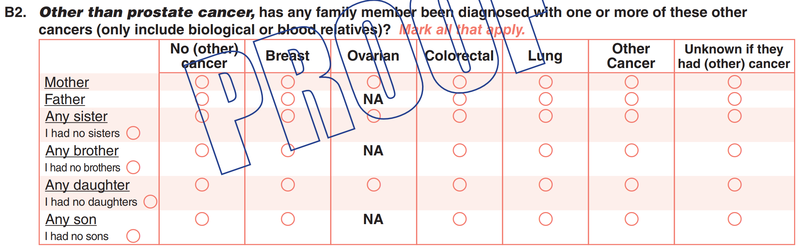

CURRENT layout:

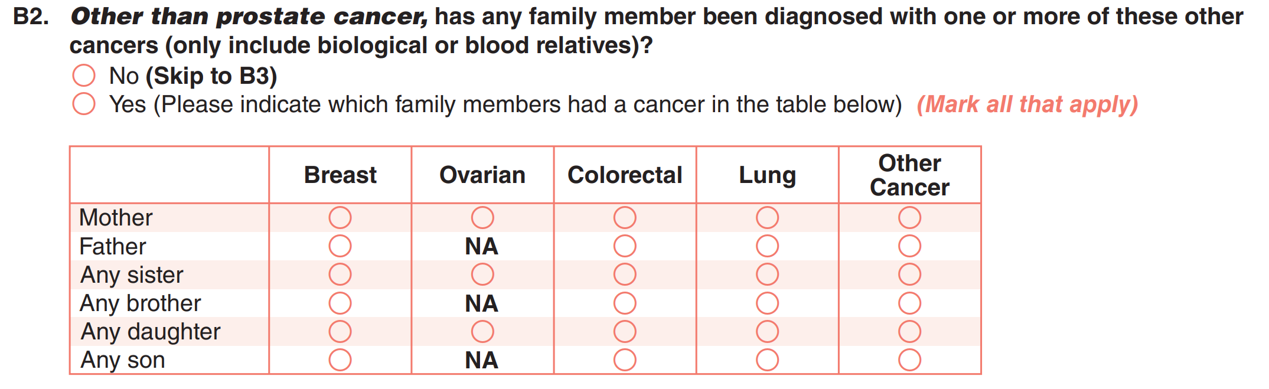

Bottom Line:

* Omit variables for all data: B2x_6, B2x_7, B2xNo [replace ‘x’ with A-F versions of variable]
* Variable B2 – ONLY available for current version of survey; Cannot know FOR SURE if null value means respondent left blank, or respondent filled EARLY version of form.

**Proposed solution**: – redo database view for survey data to OMIT above variables.

As of 7/29/2021 there are 379 surveys with ANY response to one of the 7 omitted variables affected.

*Online surveys: Are affected by this issue.

CURRENT (later) Question B2 definitions

Extracted from current Scantron TSOW - Note:

**M-302587-2 = PREV (retired) version**

**M-302587-3 = CURRENT (this) version**

|  |  |  |  |  |
| --- | --- | --- | --- | --- |
| B2 | 1 | N | B2. ***Other than prostate cancer*,** has any family member been diagnosed with one or more of these other cancers (only include biological or blood relatives)? **(Not asked on M-302587-2)** | 1=No 2=Yes |
|  |  |  | If Yes, please indicate which family members had a cancer in the table below. Mark all that apply. | |
| B2A_1 | 1 | N | Mother | 1=Breast |
| B2A_2 | 1 | N | 1=Ovarian |
| B2A_3 | 1 | N | 1=Colorectal |
| B2A_4 | 1 | N | 1=Lung |
| B2A_5 | 1 | N | 1=Other Cancer |
| B2A_6 | 1 | N | 1=No (other) cancer **(Not asked on M-302587-3)** |
| B2A_7 | 1 | N | 1=Unknown if they had (other) cancer **(Not asked on M-302587-3)** |
| B2B_1 | 1 | N | Father | 1=Breast |
| B2B_3 | 1 | N | 1=Colorectal |
| B2B_4 | 1 | N | 1=Lung |
| B2B_5 | 1 | N | 1=Other Cancer |
| B2B_6 | 1 | N | 1=No (other) cancer **(Not asked on M-302587-3)** |
| B2B_7 | 1 | N | 1=Unknown if they had (other) cancer **(Not asked on M-302587-3)** |
| B2CNo | 1 | N | Any sister | 1=I had no sisters <blank> if not marked **(Not asked on M-302587-3)** |
| B2C_1 | 1 | N | Any sister | 1=Breast |
| B2C_2 | 1 | N | 1=Ovarian |
| B2C_3 | 1 | N | 1=Colorectal |
| B2C_4 | 1 | N | 1=Lung |
| B2C_5 | 1 | N | 1=Other Cancer |
| B2C_6 | 1 | N | 1=No (other) cancer **(Not asked on M-302587-3)** |
| B2C_7 | 1 | N | 1=Unknown if they had (other) cancer **(Not asked on M-302587-3)** |
| B2DNo | 1 | N | Any brother | 1=I had no brothers <blank> if not marked **(Not asked on M-302587-3)** |
| B2D_1 | 1 | N | Any brother | 1=Breast |
| B2D_3 | 1 | N | 1=Colorectal |
| B2D_4 | 1 | N | 1=Lung |
| B2D_5 | 1 | N | 1=Other Cancer |
| B2D_6 | 1 | N | 1=No (other) cancer **(Not asked on M-302587-3)** |
| B2D_7 | 1 | N | 1=Unknown if they had (other) cancer **(Not asked on M-302587-3)** |
| B2ENo | 1 | N | Any daughter | 1=I had no daughters <blank> if not marked **(Not asked on M-302587-3)** |
| B2E_1 | 1 | N | Any daughter | 1=Breast |
| B2E_2 | 1 | N | 1=Ovarian |
| B2E_3 | 1 | N | 1=Colorectal |
| B2E_4 | 1 | N | 1=Lung |
| B2E_5 | 1 | N | 1=Other Cancer |
| B2E_6 | 1 | N | 1=No (other) cancer **(Not asked on M-302587-3)** |
| B2E_7 | 1 | N | 1=Unknown if they had (other) cancer **(Not asked on M-302587-3)** |
| B2FNo | 1 | N | Any son | 1=I had no sons <blank> if not marked **(Not asked on M-302587-3)** |
| B2F_1 | 1 | N | Any son | 1=Breast |
| B2F_3 | 1 | N | 1=Colorectal |
| B2F_4 | 1 | N | 1=Lung |
| B2F_5 | 1 | N | 1=Other Cancer |
| B2F_6 | 1 | N | 1=No (other) cancer **(Not asked on M-302587-3)** |
| B2F_7 | 1 | N | 1=Unknown if they had (other) cancer **(Not asked on M-302587-3)** |

|  |  |  |  |
| --- | --- | --- | --- |
| OLD | CURR | Missing EARLY Version | Missing CURRENT Version |
|  |  |  |  |
|  | B2 | x |  |
| B2A_1 | B2A_1 |  |  |
| B2A_2 | B2A_2 |  |  |
| B2A_3 | B2A_3 |  |  |
| B2A_4 | B2A_4 |  |  |
| B2A_5 | B2A_5 |  |  |
| B2A_6 | B2A_6 |  | x |
| B2A_7 | B2A_7 |  | x |
| B2B_1 | B2B_1 |  |  |
|  |  |  |  |
| B2B_3 | B2B_3 |  |  |
| B2B_4 | B2B_4 |  |  |
| B2B_5 | B2B_5 |  |  |
| B2B_6 | B2B_6 |  | x |
| B2B_7 | B2B_7 |  | x |
| B2CNo | B2CNo |  | x |
| B2C_1 | B2C_1 |  |  |
| B2C_2 | B2C_2 |  |  |
| B2C_3 | B2C_3 |  |  |
| B2C_4 | B2C_4 |  |  |
| B2C_5 | B2C_5 |  |  |
| B2C_6 | B2C_6 |  | x |
| B2C_7 | B2C_7 |  | x |
| B2DNo | B2DNo |  | x |
| B2D_1 | B2D_1 |  |  |
|  |  |  |  |
| B2D_3 | B2D_3 |  |  |
| B2D_4 | B2D_4 |  |  |
| B2D_5 | B2D_5 |  |  |
| B2D_6 | B2D_6 |  | x |
| B2D_7 | B2D_7 |  | x |
| B2ENo | B2ENo |  | x |
| B2E_1 | B2E_1 |  |  |
| B2E_2 | B2E_2 |  |  |
| B2E_3 | B2E_3 |  |  |
| B2E_4 | B2E_4 |  |  |
| B2E_5 | B2E_5 |  |  |
| B2E_6 | B2E_6 |  | x |
| B2E_7 | B2E_7 |  | x |
| B2FNo | B2FNo |  | x |
| B2F_1 | B2F_1 |  |  |
|  |  |  |  |
| B2F_3 | B2F_3 |  |  |
| B2F_4 | B2F_4 |  |  |
| B2F_5 | B2F_5 |  |  |
| B2F_6 | B2F_6 |  | x |
| B2F_7 | B2F_7 |  | x |